- INTRODUCTION TO SCAFFOLDING
Scaffolding is often used for working at heights (also stands) because they provide a higher degree of safety than some other work equipment and because the work is completed faster, easier and better. There are nevertheless risks associated with working on scaffolding.

- EXPLANATION & RISKS
- Scaffolds are used to:  - work at height  - work whereby both hands are needed  - work at height with frequent movements  - work at height with a storage of material nearby  - …  Types of scaffolding: fixed, mobile, standing and hanging scaffolding, rolling scaffolding, roof scaffolding, ...  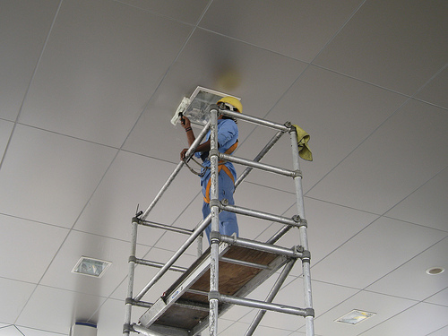  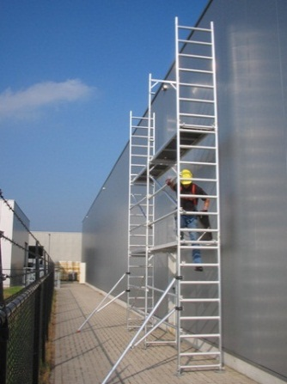 | Examples:  maintenance/beautification of canopies at filling stations  maintenance/beautification of storage tanks at depots  replacement of light bulbs  work on loading facilities at depots  maintenance/beautification of all kinds of buildings
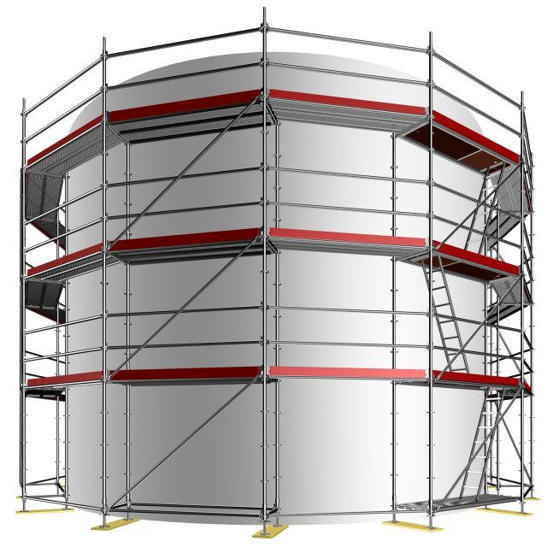

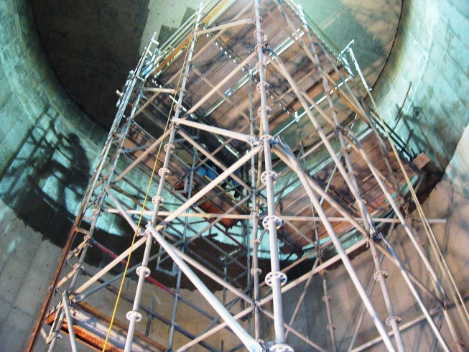

- The following risks are present:
- people falling
- material falling (work equipment, parts of the scaffold)
- collapsing/blow down of poorly constructed scaffolding

- SAFETY REQUIREMENTS
ALWAYS:
CHECK
- PERSONAL PROTECTIVE EQUIPMENT ON SCAFFOLDING
- safety helmet
- safety shoes or boots
- protective clothing, goggles and gloves if required
- + with installation, adjustment and dismantling of scaffolding
fall-protection equipment (e.g. when railing is temporarily removed)
- PREPARATION WORK WITH/ON SCAFFOLDING
- use the correct scaffold for the
    - nature of the work to be done on the scaffold
    - what work needs to be done simultaneously on the scaffold
    - total height required
    - load of the scaffold (static and dynamic)
    - how the levels can be reached with loads
    - required anchoring at buildings
    - compatibility with other work tools (e.g. pulley)
    - the ability to anchor the scaffold and add to it horizontally
    - any additional risks, e.g. electrical risks
- site preparation
    - the floor must be firm and stable, to be reinforced if necessary
    - no open excavation or activities in the vicinity that could compromise the stability of the scaffold
    - monitor rainwater and erosion on site, divert rainwater
    - sloping floors -> add support plates against shifts
    - check the quality of walls and other anchor points
    - take measures against electrical risks divert pipelines, switch off high voltage lines, isolation, grounding, ...
- storage of scaffold parts before construction
    - storage space ready and identified
    - carefully unload scaffolding parts to avoid damage and wear
    - check the state of all parts
    - replace defective parts
    - protect parts against dirt and weather conditions

ALWAYS:
CHECK
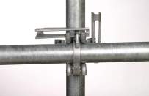
- REQUIREMENTS FOR THE CONSTRUCTION OF A SCAFFOLD
- under the supervision of a competent person (see point 6)
- scaffold documents must be present with:
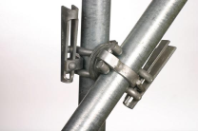
    - stability calculation
    - assembly, dismantling and alteration diagram
    - instructions for assembly, dismantling and alteration
    - maximum permissible load
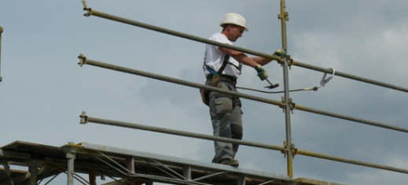
- inspection of all parts
- as close as possible against the building
- scaffold must be adequately anchored to
    - expansion bolts
    - anchors
    - ring-shaped anchors
CAUTION: DO NOT anchor to railings, support beams, rain downspouts, gutters, wooden window frames, etc. as they provide insufficient resistance
- shoring of the scaffolding is needed for reinforcement
    - without interruption to the bottom of the scaffold
    - consult the manufacturer's instructions for the position and manner of reinforcement
- safe finishing of the work floors and platforms
    - floorboards (clean)
    - edge protection (sideboards)
    - railings (respect the correct distances)
    - storage areas
    - stairs, steps, ladders
    - floor sheating or fall floors as work floor > 6 m
    - take electrical risks into account
- cover the scaffold (with nets, corrugated sheeting, ...)
    - prevent objects falling
    - protect the environment against pollution
    - protecting workers from weather
NOTE: This has an impact on the influence of wind on the scaffold, wall anchors and couplings of the wall anchors. This cannot be done for all types of scaffold (e.g. mobile scaffolding)
- sufficient and correct signage in place at unfinished scaffold
- display the red scaffold card for as long as the scaffold is not ready
(see point 5.b)

ALWAYS:
CHECK
- ACCESS TO THE SCAFFOLD
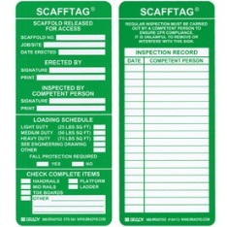
- adequate and safe access, such as
    - gangways
    - stairs - assemble as per the manufacturer's instructions
    - overrun
    - ladders - attached to the shorter side and on the inside at the foot of the scaffolding
    - inclined surfaces
- all entries must display a valid scaffold card (scafftag)
- access to the platforms must ensure safe evacuation
    - by stair towers if necessary
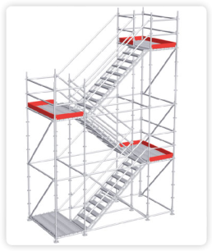
- elevator access must also be suitable for transporting persons
- CHECKS BEFORE USE
- check the scaffolding based on the following CHECKLIST:
    - all points of attention from points 3 and 4
    - keep the checklist
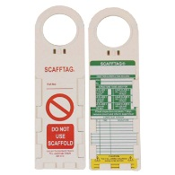
- hang up a completed scafftag in a visible place at all entrances:
    - inspection OK : green scafftag
    - inspection not OK : red scafftag with prohibition
- OWN PERSONNEL
- scaffold builder (installation, dismantling, conversion) is responsible for:
    - a competent person with the requisite knowledge to prepare the scaffold documentation and instructions (when absent)
    - training for all staff scaffold building workers for them to understand the the diagrams, to carry out their work safely and to be able to identify risks
- scaffold user(s) (scaffolding as work floor) is responsible for:
    - a competent person with the required knowledge for using the scaffolding, for inspection before use (see above) and for monitoring and measures against risks of falling
    - training for all scaffolding workers to adhere to measures against the risks of falling and to comply with instructions for safe use

ALWAYS:
CHECK
- MAINTENANCE & INSPECTION
- work floor must be well maintained / take the weather into account
- inspection for use (see also point 5)
    - before start of work
    - after an extended period of non-use
    - after each use
    - after each incident
- MOBILE SCAFFOLDING AND TOWER SCAFFOLDING - ADDITIONAL REQUIREMENTS
- 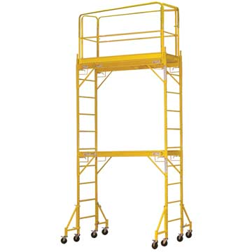height/width ratio < 3

- stable surface
3
- wheels blocked during work
- instructions for use available
- only accessible from the inside
- extra attention to stability
1
- use caution when moving (bumps and obstacles)

KUWAIT PETROLEUM NORTH WEST EUROPE

DOCUMENT TITLE: TSR - Working at height - Scaffolding

DOCUMENT NUMBER: KPNWE.WI.11.HSCO.055

REVIEW NUMBER: 1

EFFECTIVE DATE: 06 Jul 2020

NEXT REVIEW DATE: 06 Jul 2023
..

CONFIDENTIALITY:
The information contained in this document is confidential to Kuwait Petroleum International Ltd. Copyright © Kuwait Petroleum International Ltd. Copying of this document in any format is not permitted without written permission from the management of Kuwait Petroleum International Ltd.

This document is reviewed and approved according to the released online Document Approval Flow

Prepared by: | Operational Assistant | An Cornelis
Reviewed by: | Operational Assistant | An Cornelis
Approved by: | QHSSE Manager | Gerardus Timmers

*Access rights: Generally Accessible

Reviews Summary

Review date | Review reference | Review details | Review version
01 Dec 2017 |  |  | 0
06 Jul 2020 | -- | minor changes | 1

