Scope

Maintenance and repair work on electrical installations.

What and how?

Use the principle of the Vital Five!

- Disconnecting
- Locking
- Measuring
- Earthing and short-circuiting
- Cordoning off

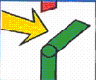
- Disconnecting

Make sure that the unit that you are working is switched off.
Ensure that is visible that the unit is switched off.

- Locking
Make sure that the installation cannot be switched on again:

- Put a notice at the switch or disconnection point prohibiting it from being switched on

or
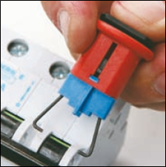
- remove the fuse or lock the fuse

- Measuring

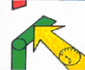
- Carry out a voltage test on each conductor forming part of the switched off installation.

    - The result must each time be 0.
    - Make sure that the measuring appliance is designed for this purpose
    - the operation of the appliance has been tested before use.

- Earthing and short-circuiting

- Earth and short-circuit each conductor in the switched off installation.

- Cordoning off

- Apply isolating plates, cloths or other materials to prevent touching live and exposed parts of other installations.

KUWAIT PETROLEUM NORTH WEST EUROPE

DOCUMENT TITLE: The vital 5 when working on electrical installations

DOCUMENT NUMBER: KPNWE.WI.11.HSCO.023

REVIEW NUMBER: 2

EFFECTIVE DATE: 15 Dec 2020

NEXT REVIEW DATE: 15 Dec 2023
..

CONFIDENTIALITY:
The information contained in this document is confidential to Kuwait Petroleum International Ltd. Copyright © Kuwait Petroleum International Ltd. Copying of this document in any format is not permitted without written permission from the management of Kuwait Petroleum International Ltd.

This document is reviewed and approved according to the released online Document Approval Flow

Prepared by: | Operational Assistant | An Cornelis
Reviewed by: | Operational Assistant | An Cornelis
Approved by: | QHSSE Manager | Patrick De Baere

*Access rights: Generally Accessible

Reviews Summary

Review date | Review reference | Review details | Review version
01 Dec 2017 |  |  | 0
01 Dec 2020 | -- | Periodic review - no changes | 1
15 Dec 2020 | -- | Periodic review- minor changes | 2

